**Capacitance**

[Modified from PASCO lab manual #77]

**Pre-lab questions:**

1. What is the goal of this experiment? What physics and general science concepts does this activity demonstrate?
2. How does the capacitance of a parallel plate capacitor depend on area of the plates? On separation distance? On material between the plates?
3. If the charge on the capacitor plates stays the same, but the measured distance between them decreases, what happens to the measured potential difference (voltage) between the plates?
4. If the charge on the capacitor plates stays the same, but a material with a larger dielectric constant (κ) is inserted, what happens to the measured potential difference (voltage) between the plates?

**Equipment:**

* Basic variable capacitor
* Basic electrometer
* 30V DC power supply
* PASCO 850 universal interface
* PASCO capstone software
* Stack of paper

The goal of the experiment is to investigate the relationship between capacitance of a parallel-plate capacitor and the separation distance of the plates. The second part of the experiment will investigate the effect on introducing a dielectric material between the plates.

**Introduction:**

A capacitor is used to store energy in the form of an electric field. A parallel-plate capacitor consists of two conductive plates insulated from one another and carrying equal, but opposite charge with magnitude *Q*. This is referred to as the “charge in the capacitor.” (In reality, the net charge on the capacitor is zero, because there is +*Q* charge on one plate, and -*Q* charge on the other.) The capacitance, *C*, of the device is the constant of proportionality between the amount of charge, *Q*, stored on each conductive plate and the potential difference, *V*, applied.

$$\begin{aligned}Q=CV \#\left(1\right)\end{aligned}$$

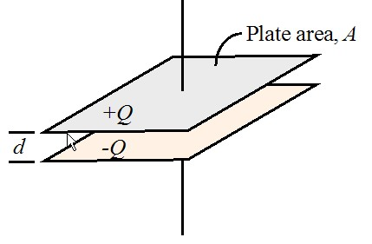

Figure 1: Diagram of a parallel-plate capacitor from PASCO EX-5533.

The capacitance of a capacitor can be shown to be dependent on the geometry of the capacitor. The simple form of a parallel-plate capacitor allows us to derive this relationship. As shown in figure 1, a parallel-plate capacitor consists of two parallel conducting plates, each with area *A*, that are separated by a relatively small distance *d*. The charge is uniformly distributed on the surface of the plates.

In lecture, you have learned that the electric field between two closely spaced parallel plates is related to the charge density on the plates and the permittivity of free space:

$$\begin{aligned}E=\frac{σ}{ϵ_{0}}=\frac{Q}{ϵ_{0}A}\#\left(2\right)\end{aligned}$$

You have also learned methods for finding the potential difference between the two plates from the electric field:

$$\begin{aligned}ΔV=V_{a}-V_{b}=-\int_{b}^{a}{\vec{E}∙d\vec{l}}\#\left(3\right)\end{aligned}$$

which simplifies for this particular case to:

$$\begin{aligned}ΔV=\frac{Qd}{ϵ_{0}A}\#\left(4\right)\end{aligned}$$

Substituting this information in equation 1, we find the relationship between the capacitance of our parallel-plate capacitor and its geometry:

$$\begin{aligned}C=\frac{Q}{V}=\frac{ϵ_{0}A}{d}\#\left(5\right)\end{aligned}$$

This equation works for a capacitor with a vacuum (or air) gap between the plates. However, you may remember that an electric field changes when it encounters a dielectric by a factor known as the dielectric constant, κ. When there is a dielectric present between the plates of the capacitor, we will modify the capacitance equation to:

$$\begin{aligned}C=\frac{κϵ_{0}A}{d}\#\left(6\right)\end{aligned}$$

In fact, you could use this equation for all parallel-plate capacitors, with the knowledge that $κ≈1$ for air. Other values for κ have been measured experimentally and can be found in tables ($κ_{paper}≈3.7$). The permittivity of free space is $ϵ_{0}=8.85×{10}^{-12} F/m$, where F is the SI unit of capacitance, the Farad.

The wiring of our experimental system creates a more complex capacitance than the simple geometric relationship we have derived. In other words, the addition of the connecting wires and the electrometer add some capacitance which is roughly equal to the capacitance of the moveable plates when the plates are 1 cm apart. This is not a negligible amount, so it cannot be ignored. Including this gives an overall capacitance of:

$$\begin{aligned}C=\frac{κϵ_{0}A}{d}+C_{sys}\#\left(7\right)\end{aligned}$$

where Csys is the capacitance of the rest of the system.

In the first part of this experiment, we will be measuring the voltage (potential difference) between the two plates as it relates to the separation distance (keeping all other variables constant). If Csys were equal to zero, the measured voltage would be $V=\frac{Q}{C}=\frac{Qd}{ϵ_{0}A}$, and we would see a linear relationship between *V* and *d*. However, because Csys is not negligible, we will see a more complex relationship:

$$\begin{aligned}V=\frac{Q}{\left({κϵ_{0}A}/d+C_{sys}\right)}\#\left(8\right)\end{aligned}$$

When *d* is large, Csys dominates the denominator of equation 8. We will need to keep this in mind as we analyze the experimental data.

In the second part of the experiment, we investigate the effect of inserting a dielectric into the gap between capacitor plates. Because adding a dielectric affects the electric field, it changes the potential difference between the plates. Any material placed between the plates of a capacitor will increase its capacitance by a factor κ, the dielectric constant, which is greater than 1 for all materials (but approximately equal to 1 for air) $C=κC_{0}$. The 0-subscript represents the original capacitance with air or vacuum in the gap between the plates. Since we have charged the capacitor plates to carry charge *Q*, which should not change during the experiment, adding a dielectric will allow us to detect a change in the capacitance through a change in the measured voltage between the plates:

$$\begin{aligned}Q=C_{0}V_{0}=\frac{C}{κϵ_{0}V_{0}}\#\left(9\right)\end{aligned}$$

so

$$\begin{aligned}V=\frac{V_{0}}{κ}\#\left(10\right)\end{aligned}$$

because $κ>1$, $V<V_{0}$ and we should see a drop in the measured voltage when we insert the paper.

## Experiment:

***Set up:***

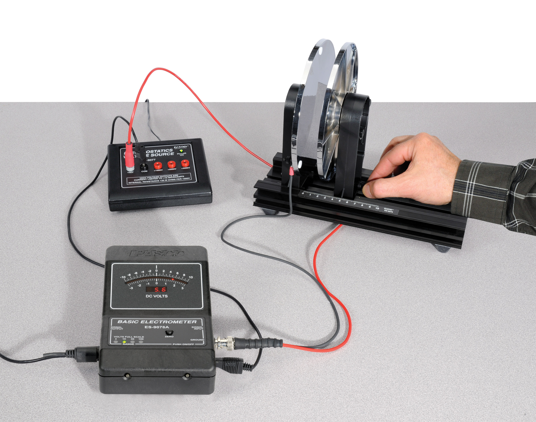

Figure 2: Equipment set up

1. Move the Variable Capacitor plates so they are about 2 mm apart. Use the adjustment screws on the back of the moveable plate to make the plates parallel.

The easiest way to do this is to look directly down from above the plates and adjust the horizontal adjust until the gap looks uniform, then look at the gap from the side and even with the center of the plates and adjust the vertical screw. You may need to repeat the process a few times.

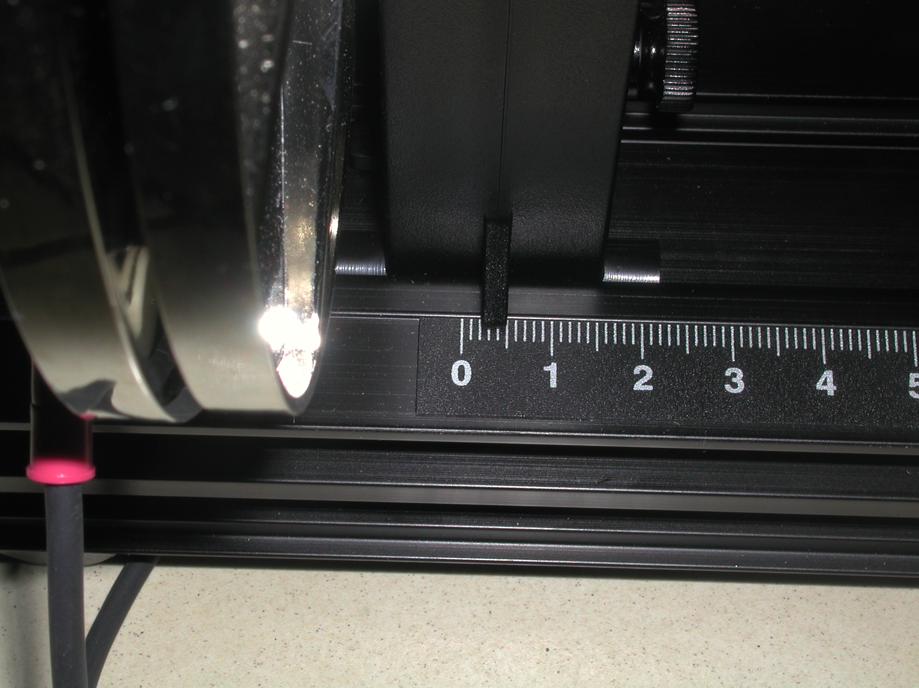

Figure 3: Detail photo of capacitor plate indicator foot

1. Position the movable plate so the leading edge of the indicator foot (see Fig. 3) is at the 0.2 cm position. The gap between the two plates should be 0.2 mm all the way around. Check it with a ruler. If the gap varies repeat step 1. If the gap is not 0.2 mm, release the holding screw on the non-moving plate and move it until the gap is 0.2 mm and then tighten the screw back down.
2. Wire the equipment as follows:
   1. Route the wires as far away from where your hand and your body will be as possible. The charges in this experiment are small so static discharge will foul things up. Also, people are conducting plates and have a significant amount of capacitance. *You can foul things up (create bad data) just by being close*.
   2. Attach the twin lead (red & black) connector to the Signal Input jack on the Basic Electrometer.
   3. It is best to make the fixed plate ground by attaching the black wire’s spade lug to it.
   4. Attach the red spade lug to the terminal on the moving plate. The wire must be free to move when the plate moves.
   5. If you have a black banana/banana wire attach it as shown from the common (com) terminal on the 30V power supply to the ground terminal on the Electrometer. [Alternately, use the provided banana/spade wire and connect the spade lead to the terminal on the fixed plate where the other ground lead is already attached.]
   6. Attach the red banana/spade lead to the +30V terminal and leave the spade end free.
   7. Plug in the transformer and apply power to the 30V power supply. Shift the switch on the back to the On position. The Power On light should glow.
3. Use the supplied adaptor cable to attach from the Signal Output on the Electrometer to the A Analog Input on the 850 Universal Interface. It is important that it be the A input!
4. In PASCO Capstone, create a table and create a user-entered data set called Separation with units of cm. Enter the values shown in Table I. Select the Voltage measurement in the second column.

Table I: Air Gap Capacitor

|  |  |
| --- | --- |
| Separation  (cm) | Voltage  (V) |
| 8.0 |  |
| 7.0 |  |
| 6.0 |  |
| 5.0 |  |
| 4.0 |  |
| 3.0 |  |
| 2.0 |  |
| 1.5 |  |
| 1.0 |  |
| 0.5 |  |
| 0.3 |  |

1. Create a graph of Voltage vs. Separation.

***Procedure:***

Procedure A: The Effect of the Plate Separation

1. Set the capacitor plates 0.3 cm apart by setting the movable plate so leading edge of its indicator foot is at the 0.3 cm mark.
2. Turn on the electrometer and set the range button to the 100 V scale.
3. Remove any charge from the capacitor by momentarily touching both plates at the same time with your hand.
4. Zero the electrometer by pressing the ‘ZERO’ button until the needle goes to zero.
5. Momentarily connect a cable from the +30V outlet in the voltage source to the stud on the back of the movable capacitor plate. This will charge the capacitor. Remove the charging cable.
6. Read the following steps (7 through 11). They need to be performed quickly since the charge will slowly escape from the electrometer, especially if the humidity is high. One person should run the computer while one moves the capacitor plate. Everyone else should stay back. Everyone should try to be in the same position for each reading. Anybody who is close is a significant part of the system and can make the readings change.
7. Slide the movable plate so it is at 8.0 cm (leading edge of the indicator foot). Once the plate is in position, the person moving the plate should move away 50 cm or so and try to be in the same position for each measurement.
8. In Capstone, click the PREVIEW button at the lower left to begin collecting data. Colored numbers will appear in first row of the table. The person doing the computer should click the Keep Sample (red checkmark in the lower left) button. The number in the first row will turn black and the colored number will move to the second row. The person at the computer should read the next separation (7 cm) out loud and wait.
9. Move the plate to 7.0 cm and repeat the process until 0.3 cm.
10. Click the STOP button to end the data collection.
11. Examine the graph. If it looks like a smooth curve, you are done. If not, repeat the process until you get a run with a smooth curve.

Procedure B: The Effect of a Dielectric between the Plates

1. In PASCO Capstone, create a table and create a user-entered data set called Paper Position with no units. Enter the values shown in Table II. Select the Voltage measurement in the second column.

Table II: Paper Dielectric

|  |  |  |
| --- | --- | --- |
|  | Paper  Position | Voltage  (V) |
| 1 | out |  |
| 2 | in |  |
| 3 | out |  |
| 4 | in |  |
| 5 | out |  |
| 6 | in |  |
| 7 | out |  |
| 8 | in |  |
| 9 | out |  |

1. You will use paper as the dielectric to be inserted between the plates. Get a stack of paper about 1 cm thick.
2. Position the movable plate of the capacitor at 8 cm.
3. Turn on the electrometer and set the range button to the 100 V scale.
4. Remove any charge from the capacitor by momentarily touching both plates at the same time with your hand.
5. Zero the electrometer by pressing the ‘ZERO’ button. The needle must be at zero.
6. Momentarily connect a cable from the +30V outlet in the voltage source to the stud on the back of the movable capacitor plate. This will charge the capacitor. Remove the charging cable.
7. Click on the PREVIEW button.
8. One student holds the stack of paper directly above the gap between the capacitor plates so that the long side of the paper is vertical.
   1. Hold the paper with one hand and keep the other hand on the metal connector attached to the signal input of the Electrometer so that there is no static charge on the student holding the paper.
   2. Press the Keep Sample button to record the voltage when the paper is not between the plates.
9. Lower the paper between the two plates until it touches the base.
   1. Do not let the paper touch either plate! If the paper touches the plate, begin the procedure again.
   2. Keep your hand as far above the plates as possible.
   3. Press the Keep Sample button to record the voltage when the paper is between the plates.
10. Pull the paper back above the plates and repeat steps 9 and 10 several times.
11. Click the STOP button to stop monitoring the data.
12. If the final voltage with the paper out is much different from the initial paper out value, you probably touched the plates and should repeat the experiment.

**Data:**

Table I: Air Gap Capacitor

|  |  |
| --- | --- |
| Separation  (cm) | Voltage  (V) |
| 8.0 |  |
| 7.0 |  |
| 6.0 |  |
| 5.0 |  |
| 4.0 |  |
| 3.0 |  |
| 2.0 |  |
| 1.5 |  |
| 1.0 |  |
| 0.5 |  |
| 0.3 |  |

Table II: Paper Dielectric

|  |  |  |
| --- | --- | --- |
|  | Paper  Position | Voltage  (V) |
| 1 | out |  |
| 2 | in |  |
| 3 | out |  |
| 4 | in |  |
| 5 | out |  |
| 6 | in |  |
| 7 | out |  |
| 8 | in |  |
| 9 | out |  |

**Computations, and Analysis:**

Analysis A using PASCO calculator and equation fitting methods

$$\begin{aligned}V=\frac{Q}{\left({κϵ_{0}A}/d+C_{sys}\right)}\#\left(8\right)\end{aligned}$$

Examination of Equation 8 from the introduction shows that if Csys = 0, then V is directly proportional to d and the Voltage vs. Separation graph on the Data page should be a straight line. This is clearly not the case. To verify Equation 8 for the case where Csys is not zero, we need to know Q and Csys. We determine these by fitting the math model (Equation 8) to the data.

First we note that

κ εo A = (1.00)*( 8.85 x 10-12 F/m)( 2.46 x 10-2 m2) = 2.18x10-13Fm = 2.18x10-11F cm.

So the parallel plate capacitance when d = 1 cm is C1.0 = 2.18x10-11 F. Note that this value is entered in line 2 of the Calculator.

When d is small (0.3 cm) the first term in the denominator dominates and

Q ~ V0.3 (κ εo A)/d = (30 V)*(2.18x10-11F cm)/(0.3 cm) = 2.2x10-9 C.

This value is entered as an initial guess for the value of Q in line 1 of the calculator. Q is constant so when d becomes large, Csys dominates in the denominator and we have:

Csys ~ Q/V8 ~ 2.2x10-9 C/80 V = 2.7x10-11 F

Where V8 is the voltage when d = 8 cm. This is taken as the initial guess for Csys (=C1) on line 3 of the calculator.

Note that Csys is about equal to C1.0 at 1.0 cm. At 0.3 cm, C0.3 = 7x10-11 F so C0.3 ~ 3 Csys and the approximation above is decent but not great. At 8 cm C8 = 2.7x10-12 F = Csys /10, so the approximation is good, but not perfect.

1. In the Calculator, create the following calculations:

‎Q‎ = 3.0*10^(-9) Units of C

‎κε₀A ‎ = 2.18*10^-11 Units of (F cm)

‎C₁‎ = 3.6*10^-11 Units of F

‎V model ‎= [Q‎]/([κε₀A‎]/[Separation]+[C₁‎]) Units of V

1. Use the Data Display button () to select your best run.
2. Adjust the values for Q on line 1 of the Calculator and for C1 on line 2 to make the model match the experimental curve as well as possible.

**Conclusions:**

1. What happened to the voltage as the plates got closer together ( decreasing)?
2. What were your best fit values for the charge Q and Csys?
3. How well did your model fit the data? Try to explain any discrepancy. Hint: What approximations are made when deriving the parallel plate capacitance (C = κ εo A/d) from Gauss’ Law?
4. Briefly discuss the value of computer modeling.
5. Examine Table II. Does the data agree with Equation 5? What does a dielectric do?

**Sources of errors:**

What assumptions were made that caused error? What is the uncertainty in your final calculation due to measurement limitations?